 

Department of Computer Science & Information Technology

III Year,V Semester(Batch 2022-2026)

Lab Record Submission of

Linux (Lab)

Subject Code – CSIT-505

Submitted to: Submitted by:

Prof. Nidhi Nigam Swapnil Kanungo

0827CI221133

**Linux Architecture**

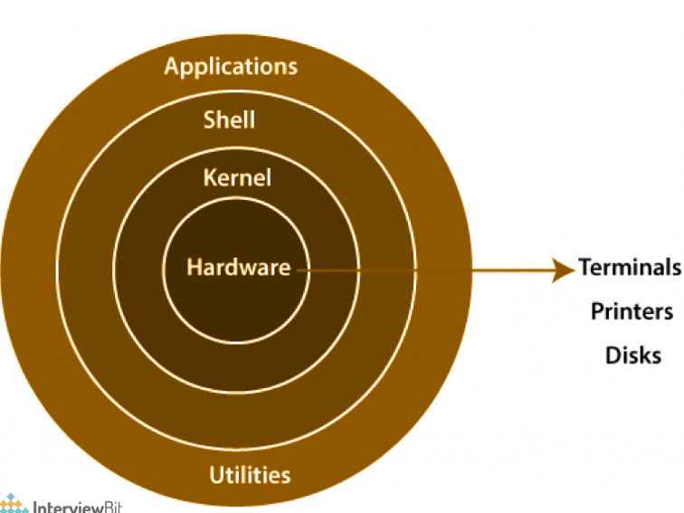

**Components of Linux**

Linux architecture can be divided into several key components:

1. **Kernel**: The core of the operating system, responsible for managing hardware resources such as CPU, memory, and I/O devices. The kernel handles system calls, process .
2. management, and memory management. It operates in two modes: user mode (where applications run) and kernel mode (where the kernel runs with full access to the hardware).
3. **System Libraries**: These are essential libraries that provide a standard API for applications. The GNU C Library (glibc) is one of the most widely used libraries, facilitating communication between the software and the kernel.
4. **System Utilities**: These are basic tools that perform fundamental tasks. Common utilities include shell commands (like bash) and system monitoring tools. They provide essential functionalities for managing the system.

**Linux File System Hierarchy**

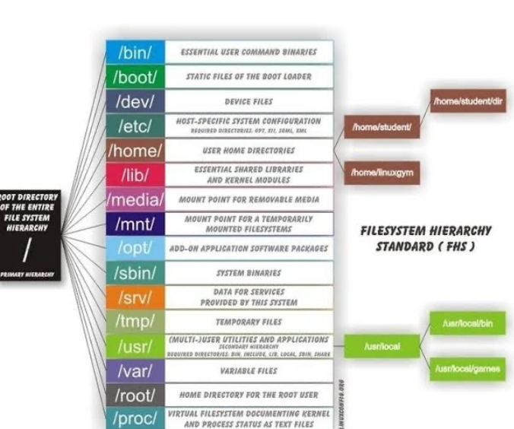

The Linux file system follows a standard directory structure, known as the Filesystem Hierarchy Standard (FHS). Key directories include:

* **/** (Root): The top-level directory in the Linux file system hierarchy.
* **/bin**: Contains essential command binaries (executables) required for the system's basic functioning.
* **/etc**: Holds configuration files that control the behavior of the system and applications.
* **/home**: Contains personal directories for users, where they can store their files and settings.
* **/lib**: Houses shared libraries essential for system operation, including modules used by the kernel.
* **/usr**: Contains user-related programs and data, including applications and utilities.
* **/var**: Stores variable data files, such as log files and databases, that change in size and content.

**Process Management**

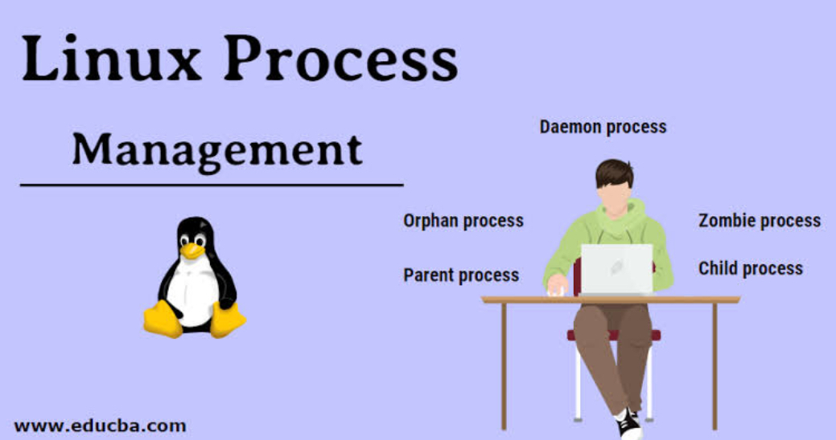

Linux efficiently manages processes, which are instances of running programs. Each process has a unique Process ID (PID) and can be in one of several states:

* **Running**: Actively executing on the CPU.
* **Sleeping**: Waiting for an event (like I/O completion).
* **Stopped**: Temporarily halted, often due to user intervention.
* **Zombie**: A terminated process that still has an entry in the process table, awaiting retrieval by its parent process.

Common commands for process management include:

* ps: Displays information about currently running processes.
* top: Provides real-time monitoring of system processes and resource usage.
* kill [PID]: Terminates a process by its PID.

**User Management**

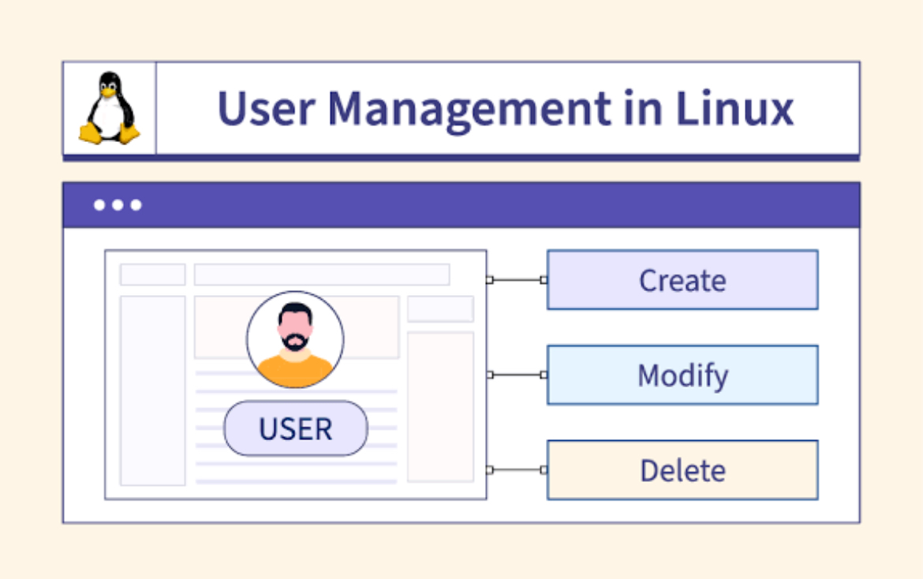

Linux employs a robust user management system, where each user has a unique User ID (UID). Users can belong to one or more groups, facilitating permission management. Key commands include:

* adduser [username]: Creates a new user.
* deluser [username]: Removes a user from the system.
* passwd [username]: Changes the password for a user.

**Shell**

The shell is a command-line interface that allows users to interact with the system. Common shells include:

* **Bash (Bourne Again Shell)**: The default shell for many Linux distributions, known for its scripting capabilities.**Zsh (Z Shell)**: Offers advanced features and better customization.
* **Fish (Friendly Interactive Shell)**: Focused on user-friendliness and interactive use.

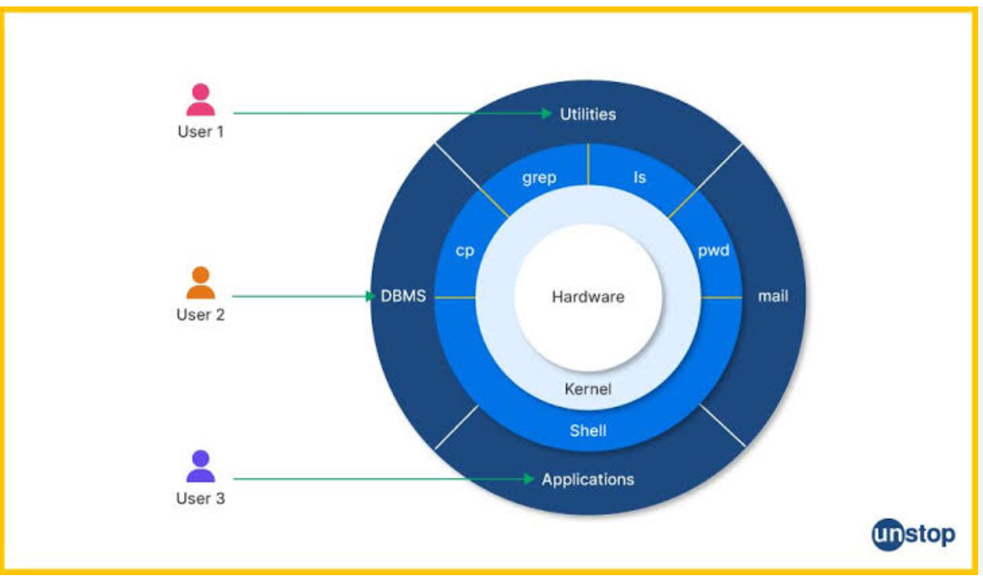

Shell scripting allows users to automate tasks by writing scripts that execute a series of commands. Scripts typically have a .sh extension and can perform complex operations using loops, conditionals, and functions.